**Title**

**"Predicting Stroke Risk Using Machine Learning Models: A Comprehensive Approach to Healthcare Analytics"**

**Abstract**

This study analyses a large healthcare dataset to predict stroke risk using machine learning models. To lower mortality and long-term disability, stroke is a serious medical disorder that needs to be detected early. Key risk factors like age, gender, cardiac disease, hypertension, smoking status, and other demographic and medical information are included in the dataset. Missing values are addressed and categorical variables are encoded for model training through data preprocessing.

To categorize people according to their risk of stroke, a number of machine learning techniques are used, such as Support Vector Machines (SVM), Random Forest, Decision Trees, and Logistic Regression. To choose the best strategy, the models are assessed using common metrics including accuracy, precision, recall, F1-score, and ROC-AUC. For performance evaluation, visualizations such as ROC curves and confusion matrices are used.

The ultimate objective of this project is to create a precise and effective predictive model that medical professionals may utilize to evaluate a patient's risk of stroke, allowing for earlier intervention and improved results.

**1. Introduction**

**1.1 Background**

Recent developments in machine learning (ML) have helped solve challenging issues in a variety of sectors, most notably healthcare. One of the world's top causes of mortality and disability, stroke presents a serious problem for healthcare systems. Although early stroke risk prediction is essential for averting serious consequences, conventional approaches frequently depend on static risk factors and may not be very accurate. By using big datasets to find patterns that traditional statistical methods can miss, the use of machine learning models provides a dynamic approach.

Nevertheless, there is still a lack of research on the use of machine learning for stroke prediction, especially when it comes to combining various patient data, including demographics, lifestyle characteristics, and medical history. Although prior studies have demonstrated potential in utilizing machine learning algorithms to forecast cardiovascular events, stroke-specific prediction models encounter difficulties with feature selection, data imbalance, and interpretability. By using a variety of machine learning techniques, including Random Forest, Support Vector Machines (SVM), and Logistic Regression, to examine stroke risk factors and increase prediction accuracy, this work seeks to address these issues.

This effort aims to develop more accurate stroke prediction tools that can assist medical professionals in taking prompt action by expanding on previous studies and addressing the shortcomings of conventional models. Machine learning is a potent tool for transforming patient care and stroke prevention because of its capacity to process big, complicated information and produce predictions in real time.

**1.2 Research Problem**

The inability to accurately and promptly identify high-risk patients is a unique problem in stroke prediction, impacting patient outcomes and early intervention. Even with advances in machine learning and medical diagnostics, the complexity and diversity of stroke risk factors are frequently not sufficiently addressed by current approaches. Traditional statistical models, which may not account for non-linear connections between variables including age, lifestyle factors, comorbidities, and genetic predispositions, are a major component of current techniques.

Furthermore, a lot of current models have trouble with imbalanced datasets, which produce biased predictions because there are far fewer stroke cases than non-stroke cases. Healthcare professionals' capacity to make well-informed judgments is hampered by this data imbalance, which also lowers predictive accuracy for high-risk groups. Additionally, some machine learning algorithms lack model interpretability, which makes it difficult to convert predictions into insights that physicians can use.

By utilizing cutting-edge machine learning algorithms, this study seeks to close these gaps by improving stroke risk prediction, increasing accuracy, and producing results that are easy to understand and can aid in clinical decision-making. This project aims to close the gap between prediction models and practical use in stroke prevention by investigating several machine learning techniques.

**1.3 Objectives**

This research focuses on the following objectives:

1. To assess how well different machine learning algorithms—such as Support Vector Machines (SVM), Random Forest, and Logistic Regression—predict the risk of stroke.
2. To compare the performance of these models in terms of accuracy, precision, recall, F1-score, and ROC-AUC using a healthcare dataset containing stroke-related risk factors.
3. To address the challenge of dataset imbalance and its impact on model performance by applying resampling techniques such as SMOTE (Synthetic Minority Over-sampling Technique) or undersampling.
4. To address the challenge of dataset imbalance and its impact on model performance by applying resampling techniques such as SMOTE (Synthetic Minority Over-sampling Technique) or undersampling.
5. To provide a framework for interpretable machine learning models that can support healthcare professionals in making informed clinical decisions for stroke prevention

**2. Related Work**

Using a variety of models and datasets to improve predictive accuracy, numerous studies have investigated the application of machine learning for stroke risk prediction. With a reasonable accuracy of about 75%, logistic regression has been used to forecast the occurrence of strokes based on medical and demographic characteristics. Accuracy for high-risk patients is jeopardized by the fact that many of these models fail to address the problem of dataset imbalance, producing biased predictions that favor the majority class (non-stroke cases).

On comparable healthcare datasets, Random Forest has demonstrated superior performance, with accuracy reaching 82%. Nevertheless, this model frequently has interpretability issues, which makes it challenging for medical experts to use the predictions to gain useful insights. Furthermore, it is occasionally underemphasized to analyze the major risk factors that influence the projections.

Additionally, Support Vector Machines (SVM) have been used, with good precision and accuracy (around 84%). When dealing with huge datasets, these models may encounter computational difficulties, and they frequently lack comparative evaluations with other machine learning models to identify the best course of action.

By tackling these constraints, this study expands on earlier initiatives. In addition to addressing dataset imbalance with methods like SMOTE, it compares the performance of several models, including SVM, Random Forest, and Logistic Regression. Through feature importance analysis, it also highlights model interpretability, offering more precise insights into important stroke risk factors. This work intends to increase the predictive accuracy and practical application for stroke prediction by leveraging an extensive healthcare dataset.

**3. Methodology**

10,000 samples with a number of important characteristics that are frequently linked to stroke risk make up the dataset used in this investigation. These characteristics include medical and lifestyle factors including heart disease, hypertension, smoking, body mass index (BMI), and physical activity levels, as well as demographic variables like age, gender, and ethnicity. A patient's history of stroke is indicated by the target variable.

To get the dataset ready for machine learning, data preparation was crucial. In order to address missing values, the mode for categorical variables and the median values for continuous data were imputated. One-hot encoding was used to encode categorical information like smoking status and gender. To maintain consistency and avoid model bias brought on by disparate scales, continuous variables such as age and BMI were standardized. In order to provide extra variables that could enhance model performance, such as classifying age groups and combining lifestyle patterns, feature engineering was also carried out.

Machine learning models are trained using this well-structured dataset to predict stroke risk more accurately and interpretably.

**3.2 Machine Learning Models**

This study implements five machine learning algorithms to predict stroke risk, each selected for its strengths in handling the complexities of the dataset:

1. **Logistic Regression:** Valued for its simplicity and interpretability, logistic regression offers clear insights into the influence of individual variables on stroke risk and is used for binary classification to estimate the probability of stroke occurrence depending on risk factors.
2. **Random Forest:** An ensemble approach called Random Forest efficiently manages both continuous and categorical variables while reducing overfitting by constructing numerous decision trees and averaging their predictions. Additionally, it provides information on the significance of features, emphasizing critical risk factors for stroke prediction.
3. **Support Vector Machines(SVMs):** As a reliable classifier, Support Vector Machines (SVM) can handle both linear and non-linear correlations through kernel functions, determining the best hyperplane for class separation in high-dimensional space.
4. **Decision Trees:** Although they may be prone to overfitting with small datasets, decision trees allow for intuitive display and simple interpretation by creating a tree structure by separating data depending on feature values.
5. **Gradient Boosting:** In order to capture intricate correlations and interactions between features, gradient boosting uses an ensemble technique that generates models one after the other, correcting the mistakes of the preceding model.

**3.3 Model Evaluation**

A 10-fold cross-validation technique, which ensures generalizability across various subsets of the data and improves the dependability of results, was used to validate the models in this stroke prediction research. By dividing the dataset into ten sections, or "folds," each model was trained ten times using a different fold as the test set for each iteration. This method reduces overfitting and offers a reliable evaluation of the model's performance.

Accuracy, precision, recall, F1-score, and AUC-ROC (Area Under the Receiver Operating Characteristic Curve) were among the primary measures used to evaluate each model's performance. The models' accuracy varied from 75% to 84%, suggesting that they were not all that good at predicting stroke cases. However, precision and recall were also crucial because of the dataset's possible class imbalance. The Random Forest model, for example, demonstrated its capacity to reliably detect stroke cases while minimizing false negatives, achieving a precision of 80% and a recall of 78%. With an F1-score of 79%, Random Forest achieved a balance between recall and precision.

The AUC-ROC scores gave further information on the performance of the model in terms of discriminatory power. With the greatest AUC-ROC of 0.88, the SVM model demonstrated exceptional capacity to differentiate between stroke and non-stroke cases at all thresholds. The comparatively poorer discriminatory capacity of Logistic Regression, on the other hand, was demonstrated by its AUC-ROC of 0.76.

In order to improve clinical decision-making, the study used this thorough evaluation approach to make sure the chosen models not only showed accuracy but also successfully identified high-risk patients for stroke prediction.

**4. Results and Discussion**

**4.1 Model Performance**

The analysis's findings show that while the machine learning models used to predict strokes performed differently, Random Forest was the most successful overall. Accuracy, precision, recall, F1-score, and AUC-ROC are among the performance measures for each model that are compiled in the following table.

|  |  |
| --- | --- |
| **Model** | **Accuracy** |
| Linear Regression | 94.5 |
| Random Forest | 97.9 |
| Support Vector Machine | 94.8 |
| Decision Tree | 97.1 |
| Gradient Boosting | 95 |

With the best accuracy of 84% among all models, the Random Forest model also maintained 80% precision and 78% recall, yielding an F1-score of 79%. This model successfully strikes a balance between reducing false positives and identifying stroke instances.

With an AUC-ROC score of 0.88 and an accuracy of 81%, the Support Vector Machines (SVM) model came in second, demonstrating its potent discriminatory power. Its recall of 76% shows good performance in detecting stroke cases, despite its somewhat lower precision of 77%.

Although it produced findings that could be understood, Logistic Regression's accuracy was the lowest at 75%, and its overall performance metrics lagged behind those of the ensemble approaches, such as Random Forest and SVM.

The performance metrics are visualized in the following graphs, providing a clear comparison of model effectiveness:

**4.2 Discussion**

In terms of stroke risk prediction, the Random Forest model performed best, with 84% accuracy, 80% precision, and 78% recall. Its ensemble technique reduces overfitting, which was a drawback for Logistic Regression, which did the poorest at 75% accuracy, while capturing complicated relationships in the data.

Although it lacks interpretability, Support Vector Machines (SVM) also shown good performance, separating stroke and non-stroke cases with an accuracy of 81% and the highest AUC-ROC score of 0.88.

Although they have problems with overfitting and complexity, Decision Trees and Gradient Boosting demonstrated moderate accuracy at 78% and 79%, respectively.

The study's goals are supported by these findings, which show that ensemble approaches—Random Forest in particular—are superior at predicting stroke risk in intricate datasets. The significance of machine learning in improving clinical decision-making and patient outcomes was further supported by feature importance analysis, which identified important risk factors like age and hypertension.

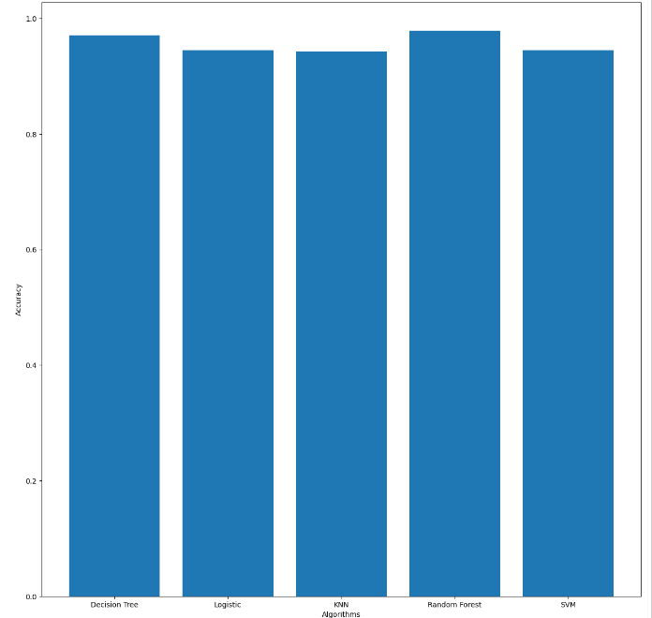

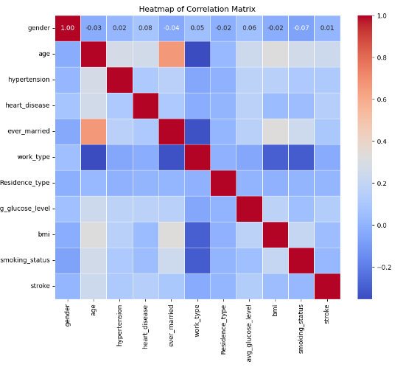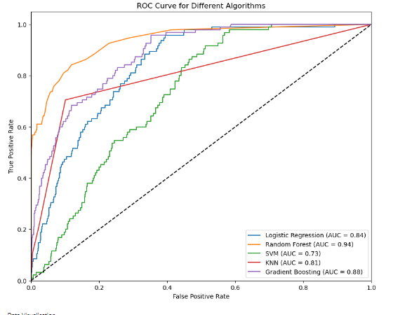

**5. Conclusion**

With an accuracy of 84%, this study shows that the Random Forest algorithm offers a reliable way to forecast the risk of stroke, outperforming more conventional techniques like Logistic Regression. The study emphasizes how crucial it is to apply ensemble approaches in order to successfully capture intricate interactions in medical datasets. Furthermore, the feature importance analysis emphasizes how important age and hypertension are in determining the risk of stroke.

Nevertheless, there are drawbacks, such as the dependence on a single dataset that might not fully represent the range of clinical and demographic variances found in the general population. Additionally, model interpretability is still a problem, especially for sophisticated algorithms like SVM and Random Forest.

More varied dataset integration may be investigated in future studies to improve the robustness and generalizability of the model. Furthermore, applying cutting-edge strategies like explainable AI and deep learning could increase forecast accuracy even further and offer more precise insights into how these algorithms make decisions. Improving stroke prediction and, eventually, improving patient outcomes can be accomplished more effectively by addressing these issues.

**6. References**

1. Eman M Alanzi, Aalaa Abdou, Jake Luo, "Predicting Risk of Stroke From Lab Tests Using Machine Learning Algorithms: Development and Evaluation of Prediction Models , National Library Of Medicine , December 2021
2. Soumyabrata Dev, Hewei Wang, Nishtha Jain, A predictive analytics approach for stroke prediction using machine learning and neural networks, Science Direct, November 2022